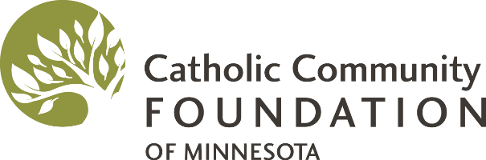

Early Catholic Family Life Program
Grant Application

Before you apply, contact Alan or Joanne Foley at Early Catholic Family Life at 612.704.7306 or alanfol@gmail.com to schedule the leader training and confirm the anticipated costs.

Your Name
Your Role with the Parish
(e.g., parent, volunteer, staff person, etc.)
Your Email
Your Phone Number
Pastor Name
Has your pastor approved this endeavor?
(Your parish will cover the costs up front. CCF will reimburse the parish when the program is completed. CCF cannot reimburse individuals.)
Church Name
Church Address
Names of 2 Confirmed Leaders | 1.  2.
Names of 2-3 Possible Volunteers to Assist | 1.  2.  3.
Number of Families Anticipated to Participate
Anticipated Expenses
(As determined in consultation with Alan or Joanne Foley.)

Submit this completed form to CCF via email at nelsonm@ccf-mn.org by April 27, 2018. If funds remain, a second deadline will be announced. Grants will be awarded on a rolling basis and parishes with Catholic schools and parishes serving Latino communities are particularly encouraged to apply.

